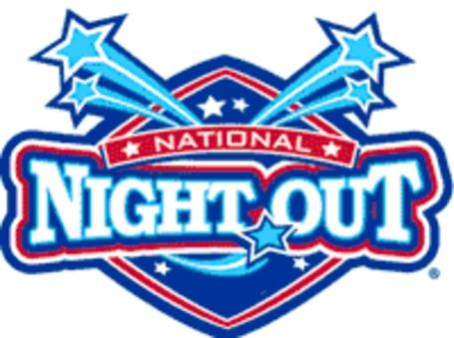
Sponsors Provide
BBQ Hot Dogs – Buns
Chilled Salads
Beverages
Paper products
Please Bring
Commercially prepared
Chips
Desserts - Fruit
Community
Pot Luck

Tuesday August 1, 2017
6:00 pm
Downtown
Glock Block
- Face Painting
Good Neighbors
Music

Sponsored By:
Mt. Angel Sausage Company

Mt. Angel Mt. Angel City of Mt. Angel
Police Department Fire Department Mt. Angel Chamber of Commence

